**Project Design Phase-II**

**Technology Stack (Architecture & Stack)**

|  |  |
| --- | --- |
| Date | 17 October 2022 |
| Team ID | PNT2022TMID45424 |
| Project Name | Project -Emerging method for early detection of forest fire |
| Maximum Marks | 4 Marks |

**Technical Architecture:**

Guidelines:

1. Include all the processes (As an application logic / Technology Block)
2. Provide infrastructural demarcation (Local / Cloud)
3. Indicate external interfaces (third party API’s etc.)
4. Indicate Data Storage components / services
5. Indicate interface to machine learning models (if applicable)

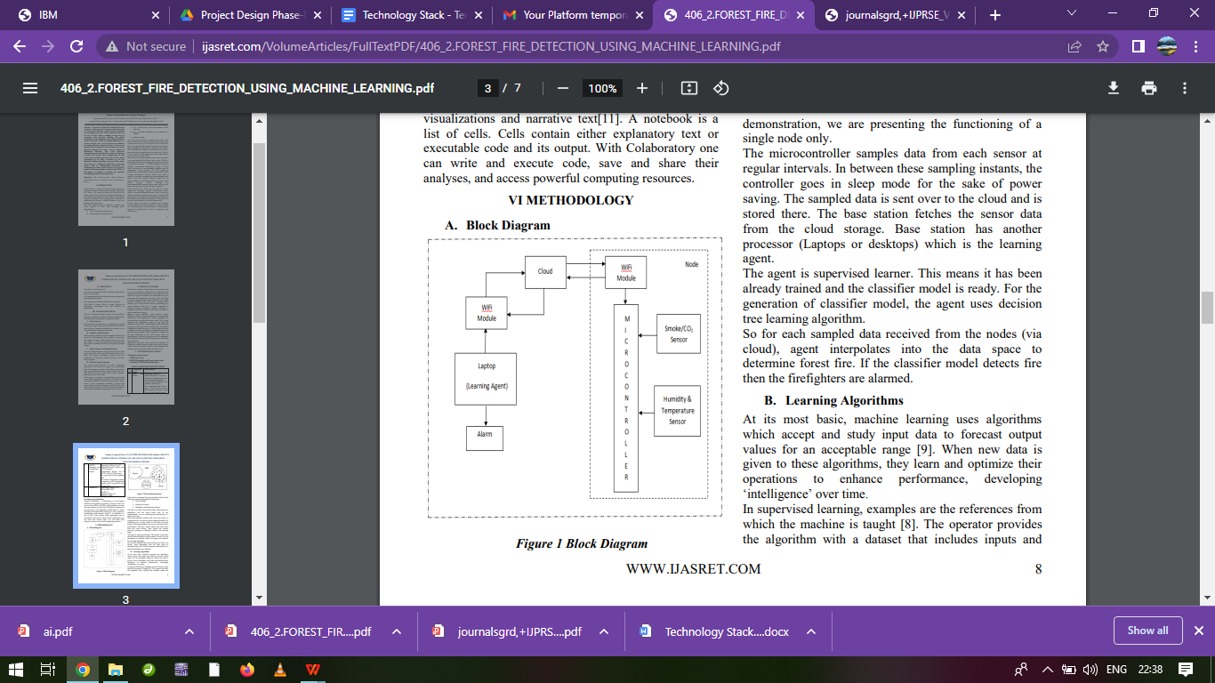

**Table-1 : Components & Technologies:**

|  |  |  |  |
| --- | --- | --- | --- |
| **S.No** | **Component** | **Description** | **Technology** |
|  | User interface | By WWAN ,user interacts with application e.g.Web UI, Mobile App, Chatbot etc. | HTML, CSS, JavaScript / Angular Js / React Js etc. |
|  | Database | Phyton,keras,tensorflow,Natural language processing | MySQL, NoSQL,ResNet-50 with SVM ,  etc. |
|  | Cloud Database | Analysis Database Service on Cloud | IBM DB2, IBM Cloudant etc. |
|  | File Storage | File storage requirements | IBM Block Storage or Other Storage Service or Local Filesystem |
|  | WIFI module | wireless router creates a wireless network for your WiFi-enabled devices to connect to the Internet | WWAN 802.11,ESP8266 |
|  | Micro-controller | samples data from each sensor at  regular intervals. | Open source,integrated circuit designs |
|  | Laptop | Learning agent | Intel Core i7 8th Gen. |
|  | Sensors | (Humidity & Temerature,Smoke & CO2)It sense the changes in air atmosphere. | IBM Weather API, etc. |
|  | External API | (Alarm)sending out signals to a central monitoring station when sensors are faulted. | Wireless Alarm Systems, etc. |
|  | Machine Learning Model | Machine Learning and Transfer Learning to recognise fires in images/video frames. | Object Recognition Model, etc. |
|  | Infrastructure (Server / Cloud) | Application Deployment on Local System / Cloud  Local Server Configuration:Operating system  Cloud Server Configuration :Cloud Hosting Services | Local, Cloud Foundry, Kubernetes, etc. |

**Table-2: Application Characteristics:**

| **S.No** | **Characteristics** | **Description** | **Technology** |
| --- | --- | --- | --- |
|  | Open-Source Frameworks | It is publicly available for commercial and non-commercial use under various open source licenses | Tensorflow,RNN |
|  | Security Implementations | Use of alarm and sensors for security purpose. | Wireless Alarm Systems,Infrared (IR),Ionization/Photoelectric sensors |
|  | Scalable Architecture | Well monitoring system with accurate  indication. | Artificial Intelligence(AI) |
|  | Availability | Use of micro-controller | C++ , Java,etc |
|  | Performance | application is affordable, robust, reliable and provides high performance | Machine(or)deep learning |